**daA1920-160um/S-Mount**

The daA1920-160um S mount Basler dart USB 3.0 camera module is equipped with a Sony IMX392 sensor.

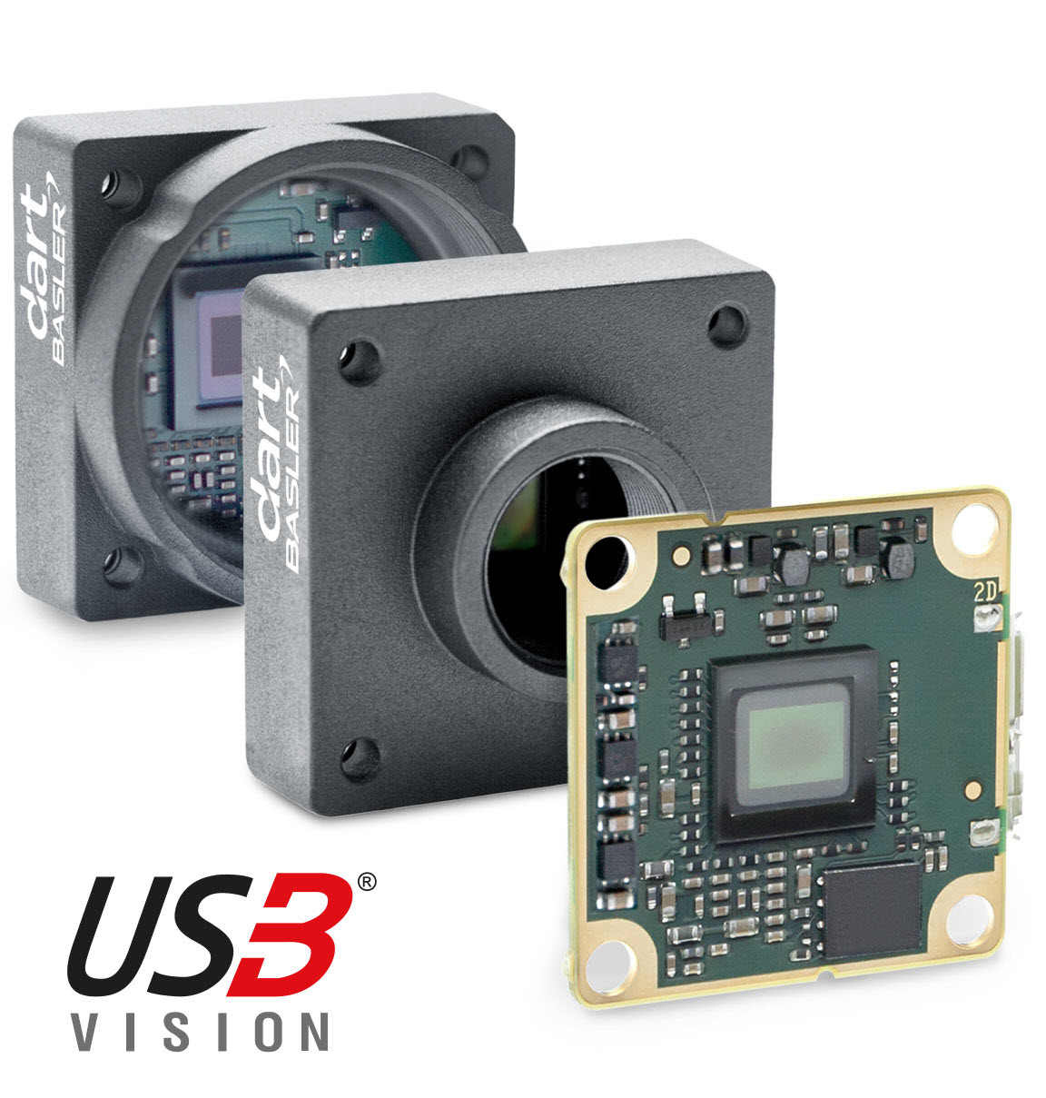

**Variants**

* **S-mount:** Consists of a circuit board and a camera front. S-mount lenses can be mounted in the lens mount on the camera front.

**Specifications**

**General Specifications**

|  | daA1920-160um |
| --- | --- |
| Resolution (H x V Pixels) | 1936 x 1216 (full resolution) 1920 x 1200 (default resolution) |
| Resolution | 2.3 MP |
| Sensor Type | Sony IMX392LLR-C Progressive scan CMOS Global shutter |
| Sensor Format | 1/2.3" |
| Effective Sensor Diagonal | 7.9 mm |
| Pixel Size (H x V) | 3.45 x 3.45 µm |
| Frame Rate | 67 fps (default settings) 164 fps (default setings, disabled Device Link Throughput Limit) |
| Mono / Color | Mono |
| Image Data Interface | USB 3.0, nominal max. 5 Gbit/s (SuperSpeed) |
| Pixel Formats | See Pixel Format. |
| Synchronization | Via hardware trigger Via software trigger Via free run |
| Exposure Time Control | Programmable via the camera API |
| Camera Power Requirements | ≈1.9 W (typical) @ 5 VDC |
| I/O Lines | 4 general purpose I/O (GPIO) lines |
| Lens Mount | S-mount, CS-mount, without mount (bare board) |
| Size (L x W x H) | S-mount and CS-mount models: 20 x 29 x 29 mm Bare board model: 8 x 28.3 x 27 mm |
| Weight | S-mount and CS-mount models: <15 g Bare board model: <5 g |
| Conformity | CE (includes RoHS), EAC, UL Listed, GenICam 2.x (including PFNC 1.x and SFNC 2.x), USB3 Vision, REACH, FCC, KC Certificates for your camera model For more information, see the Compliance section of the Basler website. |
| Software | Basler pylon Software Suite (version 6.0 or higher) Available for Windows, Linux x86, Linux ARM, macOS, and Android |
| Accessories | Lenses –  Evetar Lens E3417A F2.4 f2.5mm 1/1.8" 2200001056  Evetar E3417A IR-Cut F2.4 f2.5mm 1/1.8" 2200001057  Evetar Lens E3360A F2.0 f4.0mm 1/1.8" 2200001058  Evetar E3360D IR-Cut F2.0 f4mm 1/1.8” 2200000589  Evetar Lens E3388 F2.6 f7.8mm 1/1.8" 2200001060  Evetar E3388 IR-Cut F2.6 f7.8mm 1/1.8" 2200001061  Cables -  USB Cable - with screwlock 2200000620  USB Cable - with screwlock 2200000621  USB Cable - without screwlock 2000035131  USB Cable - without screwlock 2000035315  GigE Cable - with screwlock 2200000622  Mounting Covers –  Dart Mounting Cover 2200000959 |

Drawing –

