**a2A2840-48umUV**

The a2A2840-48umUV Basler ace 2 X camera is equipped with a Sony IMX487 sensor.

This ultraviolet (UV) camera with a USB 3.0 interface can capture images in the invisible light spectrum with wavelengths from 200–400 nm, the most suitable UV range for industrial inspections.

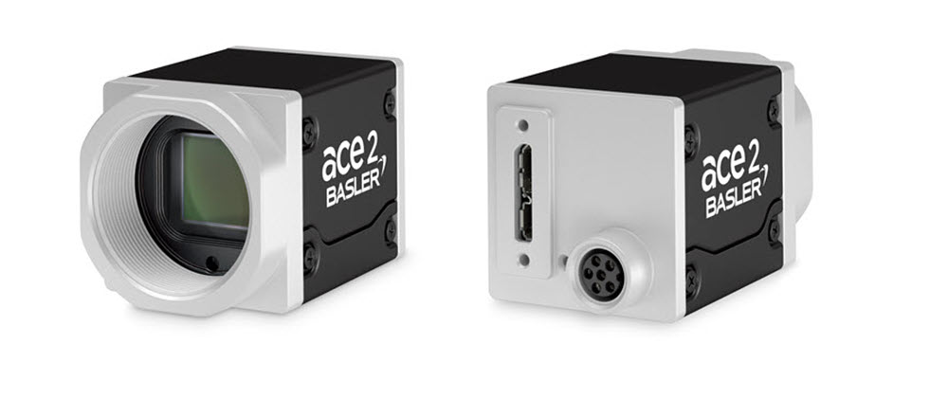

**Specifications#**

**General Specifications#**

|  | a2A2840-48umUV |
| --- | --- |
| Resolution (H x V Pixels) | 2856 x 2848 (full resolution) 2840 x 2840 (default resolution) |
| Resolution | 8 MP |
| Sensor Type | Sony IMX487-AAMJ-C Progressive scan CMOS Global shutter |
| Sensor Format | 2/3" |
| Effective Sensor Diagonal | 11.1 mm |
| Pixel Size (H x V) | 2.74 x 2.74 µm |
| Frame Rate (at Default Settings) | 44.6 fps 48.3 fps (Device Link Throughput Limit mode set to Off) |
| Product Family | ace 2 X |
| Mono / Color | Mono |
| Image Data Interface | USB 3.0, nominal max. 5 Gbit/s (SuperSpeed) |
| Pixel Formats | See Pixel Format. |
| Synchronization | Via hardware trigger Via software trigger Via free run |
| Exposure Time Control | Via hardware trigger Programmable via the camera API |
| Camera Power Requirements | ≈3.3 W (typical) @ 5 VDC when supplied via the camera's USB 3.0 port ≈3.4 W (typical) @ 12–24 VDC when supplied via the camera's I/O connector |
| I/O Lines | 1 opto-coupled input line 2 general purpose I/O (GPIO) lines |
| Lens Mount | C-mount |
| Size (L x W x H) | 36.3 x 29 x 29 mm (without lens mount or connectors) 48.1 x 29 x 29 mm (with lens mount and connectors) |
| Weight | <90 g |
| Conformity | CE (includes RoHS), EAC, UL (in preparation), FCC, KC, GenICam, USB3 Vision, IP30 Certificates for your camera model For more information, see the Compliance section of the Basler website. |
| Software | Basler pylon Software Suite (version 6.0 or higher) Available for Windows, Linux x86, Linux ARM, macOS, and Android |

Lenses –

2200002148 AZURE-00202XZMUV-1 AZURE-00202XZMUV-1 UV Lens 25.0mm FL

2200002149 AZURE-00302XZMUV-1 AZURE-00302XZMUV-1 UV Lens 35mm FL

2200002150 AZURE-00503XZMUV-1 AZURE-00503XZMUV-1 UV Lens 50mmFL

2200002151 AZURE-00705XZMUV-1 AZURE-00705XZMUV-1 UV Lens 75mm FL

Cables –

USB Cable - with screwlock 2200000620

USB Cable - with screwlock 2200000621

USB Cable - without screwlock 2000035131

USB Cable - without screwlock 2000035315

M8, 5m, axial - Lighting Cable 2200000899

Drawing –

Please contact OEM Automatic for technical assistance.

Email: [vision@oem.co.uk](mailto:vision@oem.co.uk)

Telephone: 01162849900