Basler Cable USB 3.0, Micro B sl/A, S#
USB 3.0 cable for data transmission with type A plug to Micro-B plug.
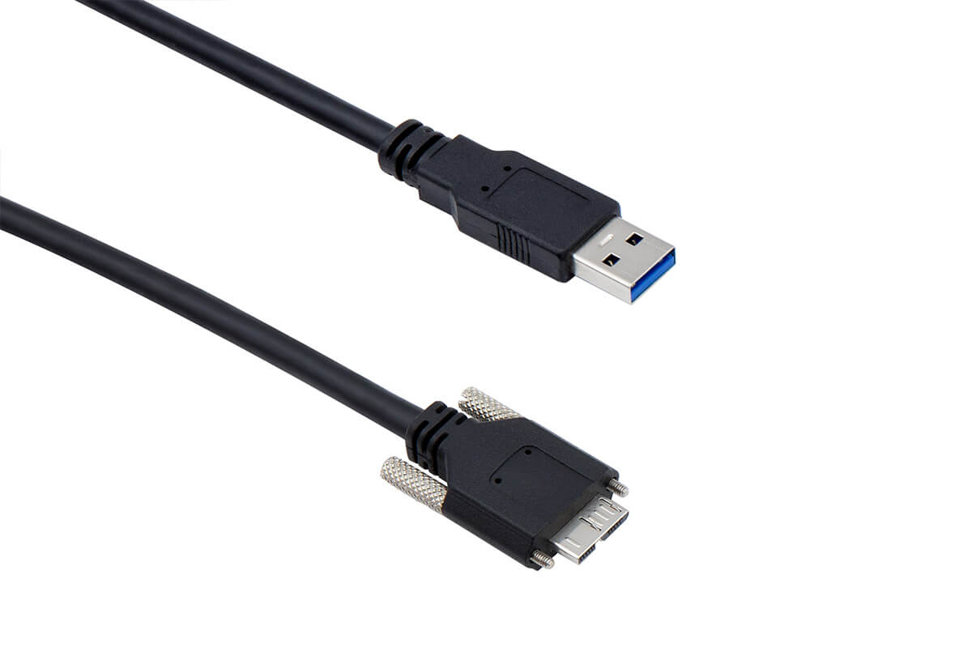
Info
The cable is suitable for ace and ace 2 cameras.
Order Number | Cable Length
2200000620 | 1 m
2200000621 | 3 m
Cable Drawing#
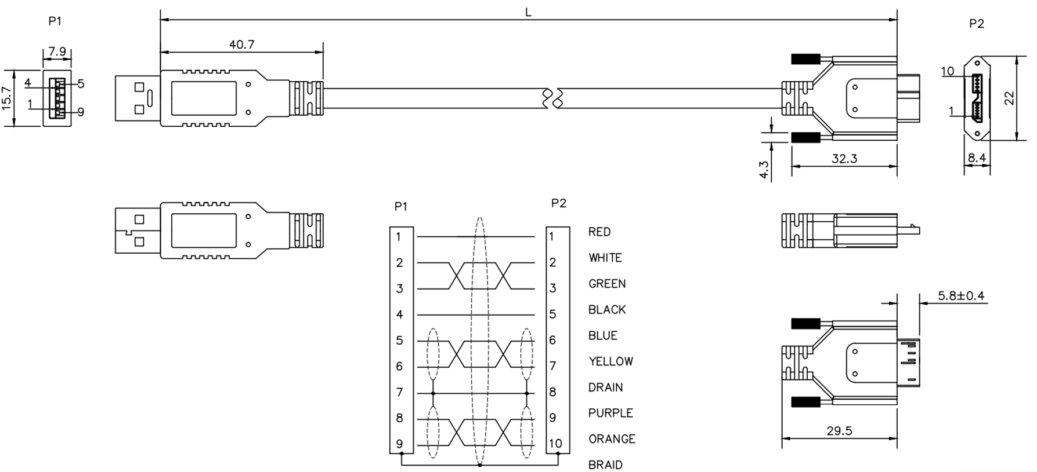
Transfer Rates#
 | 2200000620 / 2200000621
USB 2.0 | 480 Mbps
USB 3.0 | 5 Gbps
Physical Specifications#
 | 2200000620 / 2200000621
Camera-Side Connector | Micro-B with screw lock
Host-Side Connector | Type A, USB-IF-compliant
Cable Diameter | 5.7 mm max.
Minimum Bending Radius | 28 mm, fixed installation
Maximum Bending Cycles | None (fixed installation only)
Suitable for Drag Chain Applications | No
Suitable for Robotics Applications | No

