**Cable GigE M12, M, 8P/RJ45#**

GigE cable for data transmission with an M12 8-pin connector on the camera side and RJ-45 plug on the host side.

| Order Number | Cable Length |
| --- | --- |
| 2200000614 | 2 m |
| 2200000284 | 10 m |

**Cable Drawing**

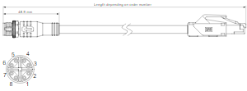

**Physical Specifications**

|  |  |
| --- | --- |
| Camera-Side Connector | M12 8-pin, male plug, X standard coding (IEC 61076-2-109) |
| Host-Side Connector | RJ45 |
| Cable Diameter | 6.4 mm |
| Outer Jacket | Black PVC |
| Minimum Bending Radius | 10 x cable diameter, fixed installation |
| Maximum Bending Cycles | None (fixed installation only) |
| Suitable for Drag Chain Applications | No |
| Suitable for Robotics Applications | No |

**Plug Specification#**

|  |  |
| --- | --- |
| Protection Rating | IP67 in locked position |