**Power-I/O Cable M12, M, 8P/Open**

Power-I/O cable with M12 8-pin connector and open end.

| Order Number | Cable Length |
| --- | --- |
| 2200000276 | 10 m |

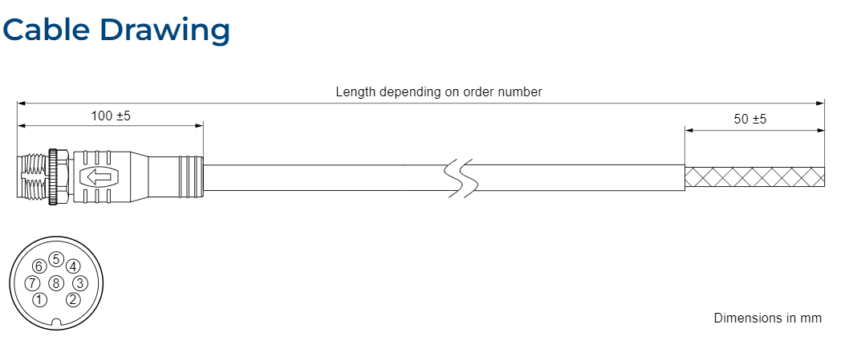

**Wiring Information**

| Pin Number | Wire Color | Function |
| --- | --- | --- |
| 1 | White | Camera Power VCC |
| 2 | Brown | Camera Power Ground |
| 3 | Green | Camera Power Ground |
| 4 | Yellow | Opto-coupled Output |
| 5 | Gray | Opto-coupled GND |
| 6 | Pink | Opto-coupled Input |
| 7 | Blue | Camera Power VCC |
| 8 | Red | Reserved, do not connect |

**Physical Specifications**

|  |  |
| --- | --- |
| Camera-side Connector | M12 8-pin, male plug, A standard coding (IEC 61076-2-101) |
| Host-side Connector | None, open end |
| Cable Cross-section | 8 × 0.25 mm² (AWG 24) |
| Cable Diameter | 5.5 mm |
| Wire Insulation Cable Shielding | Tinned braided copper, min. 80 % coverage |
| Outer Jacket | PUR, black, halogen-free |
| Minimum Bending Radius | 12 x cable diameter |
| Suitable for Drag Chain Applications | No |
| Suitable for Robotics Applications | No |

**Electrical Specifications#**

|  |  |
| --- | --- |
| Maximum Operating Voltage | 30 VDC |
| Maximum Rated Current | 2 A |
| Wire Resistance | 2200000613 (2 m): 0.17 Ω (typ.) 2200000276 (10 m): 0.87 Ω (typ.) |